Shavington-cum-Gresty Parish Council

NOTICE OF VACANCY
Shavington Village Ward

There is a vacancy in the office of Parish Councillor for Shavington Village Ward in the parish of Shavington-cum-Gresty.

Any request for an election to fill the vacancy should be made in writing to:

The Returning Officer
Cheshire East Borough Council, Westfields, Middlewich Road, Sandbach, CW11 1HZ
within FOURTEEN days (excluding Saturdays, Sundays and Bank Holidays) of the date of this notice signed by at least TEN ELECTORS of the parish in question.

If no such election be requested, the vacancy will be filled by co-option by the Parish Council within 60 days of this notice or as soon after as practicable.

Information on the procedure for the filling of casual vacancies can be obtained by writing to the Returning Officer or by telephoning (01270 686480).

Signed: 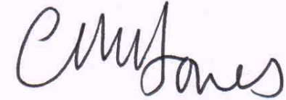 (Clerk)

Date: 21 October 2017

You may also contact Carol Jones, the Clerk, for further information about the procedure for co-option (01270 812065, or e-mail carol.jones57@outlook.com)

The deadline date for electors to call an election is 10 November 2017. In the event of no election being called, the Parish Council will aim to consider nominations for co-option at its meeting on 6 December 2017 at Shavington Village Hall, at 7.15 pm.

